**Alerting and troubleshooting events.**

**Recent event with a DC not responding correctly.**

Paged by Network Operations Center

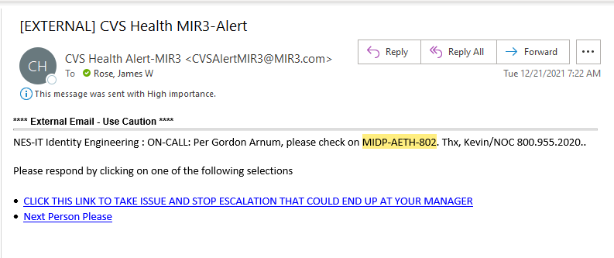

**After troubleshooting needed to have Enterprise Lan Center reboot it at the console.**

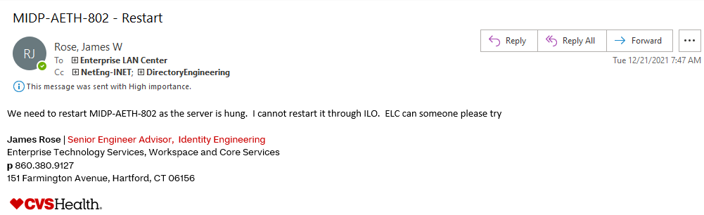

**Communications with team and management**

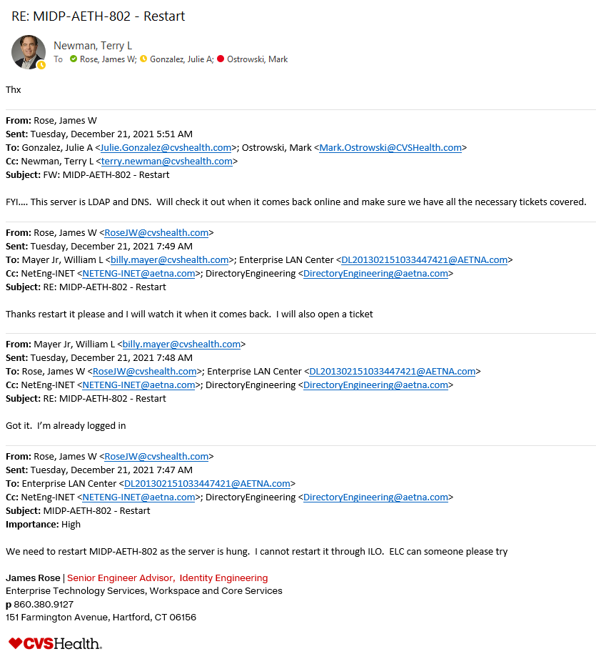

**Server was rebooted and a post reboot change completed.**

**Root cause was unknown after review of all available logs and information. Restarted and monitored server after the event to ensure stability.**

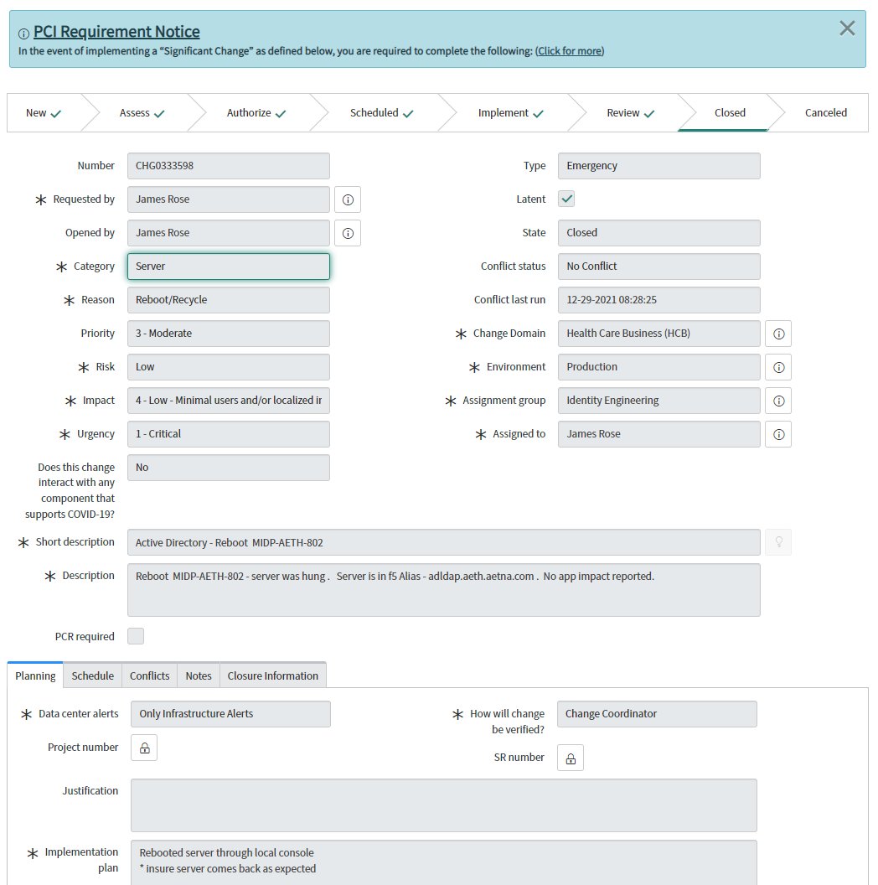

**Server low memory alert from splunk and a scheduled reboot.**

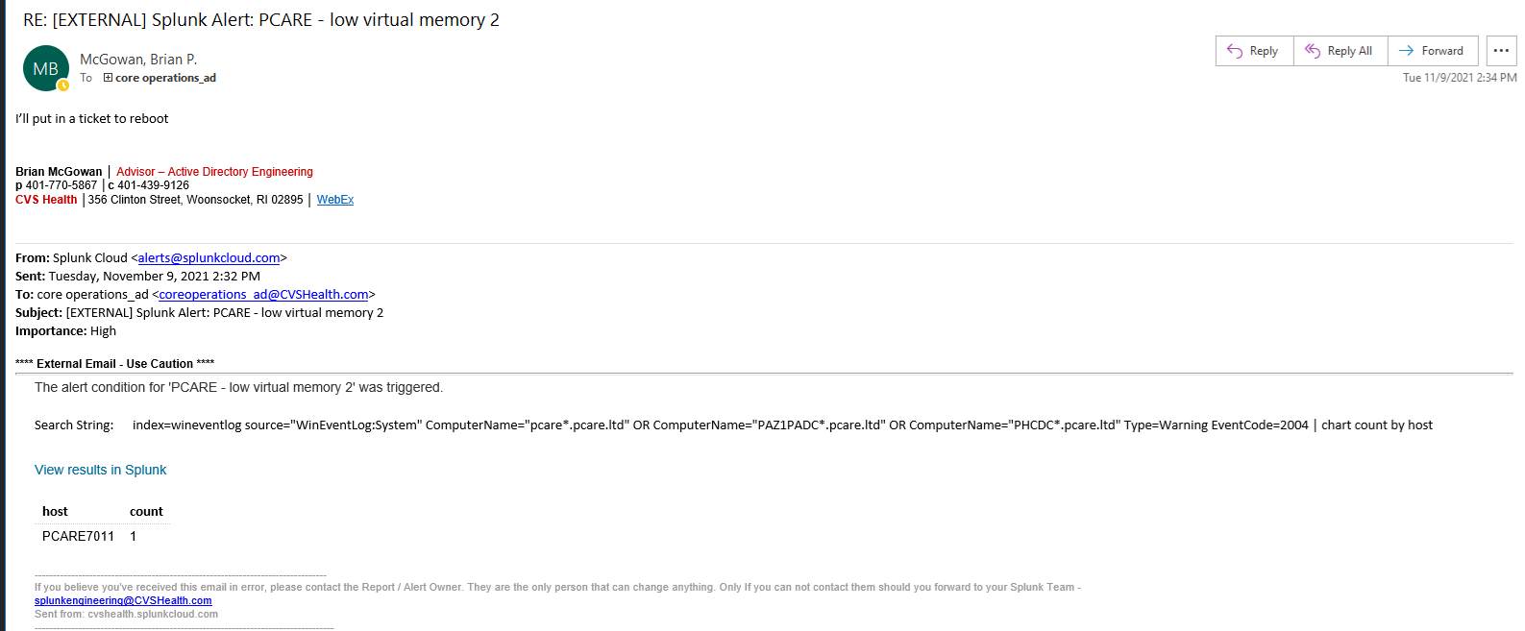

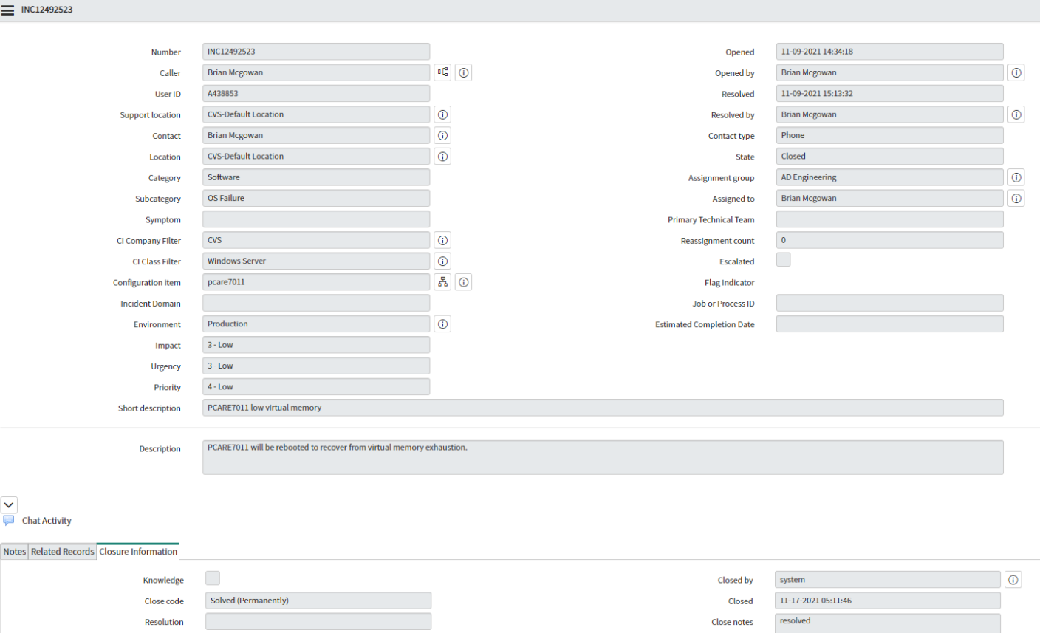

**SCOM Alerts to team**

Warning that CPU is spiking. This will happen depending with load. We will watch and make sure it returns to normal levels. Alert for 85% CPU we setup so that we can monitor.

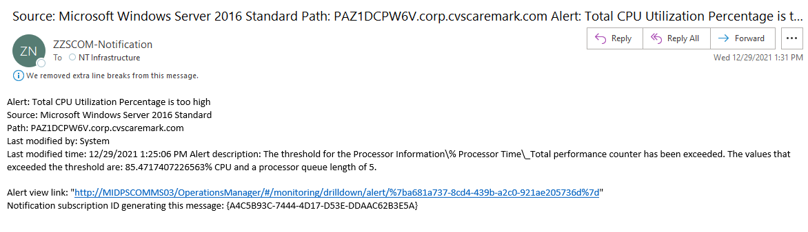

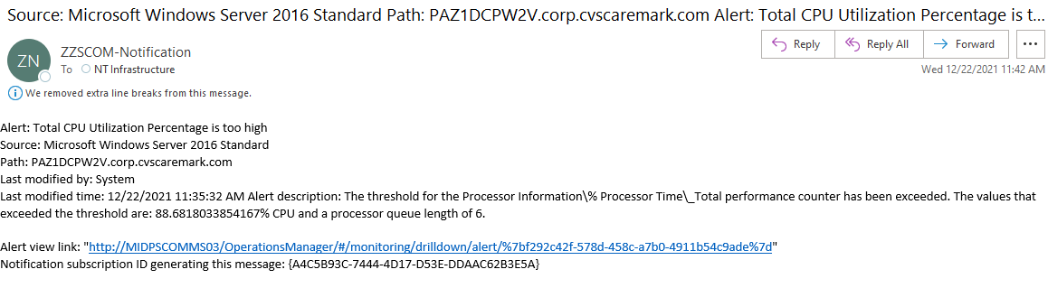

**AD Bind latency alerts because of load/high CPU for which we got paged in to look. Load cleared and CPU went back to normal.**

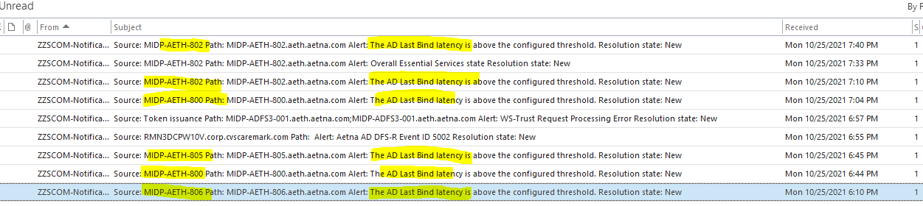

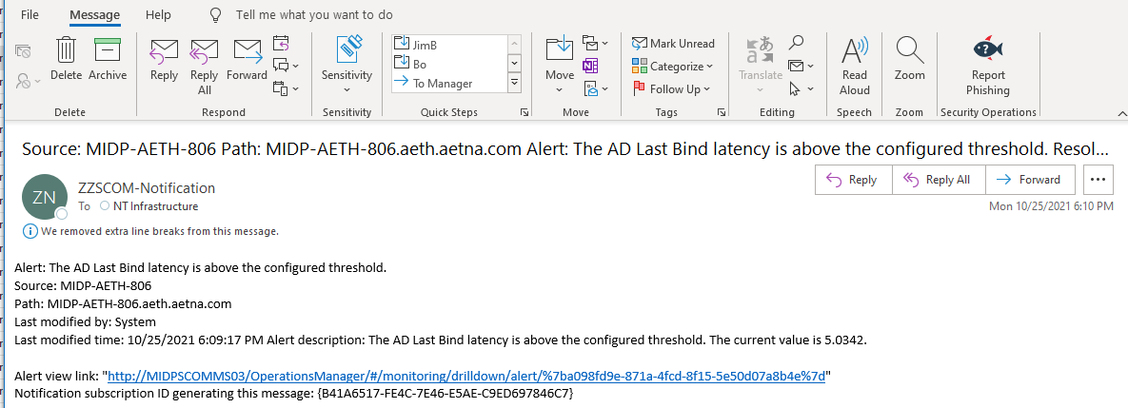

Additional Tivoli page alerts of for high CPU. I believe over 95%.

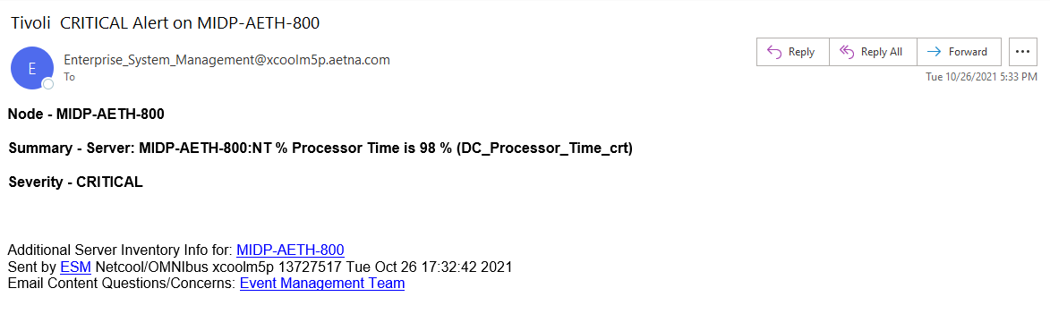

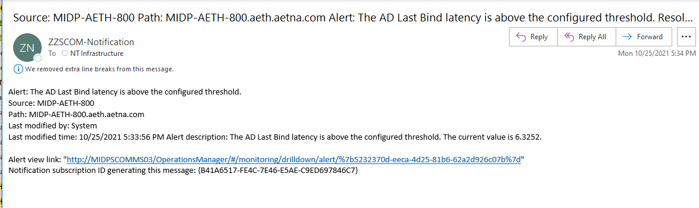

**SCOM/Squared up Dashboard**

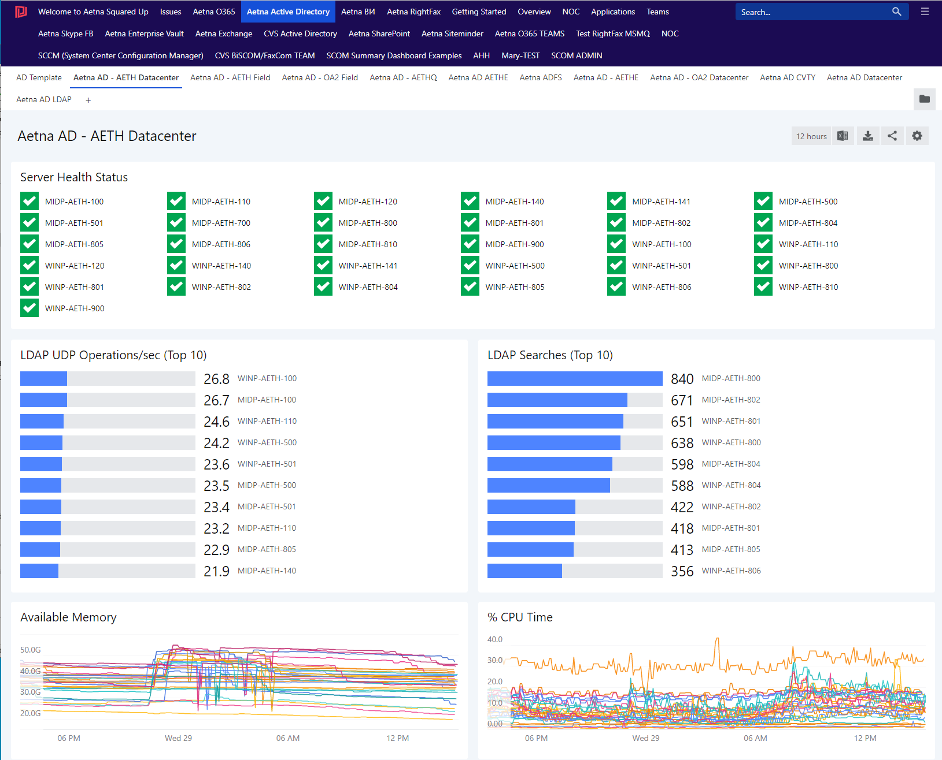

**CVS DC in red has a warning because firewalls are not open to all DC’s.(aetna.com)**

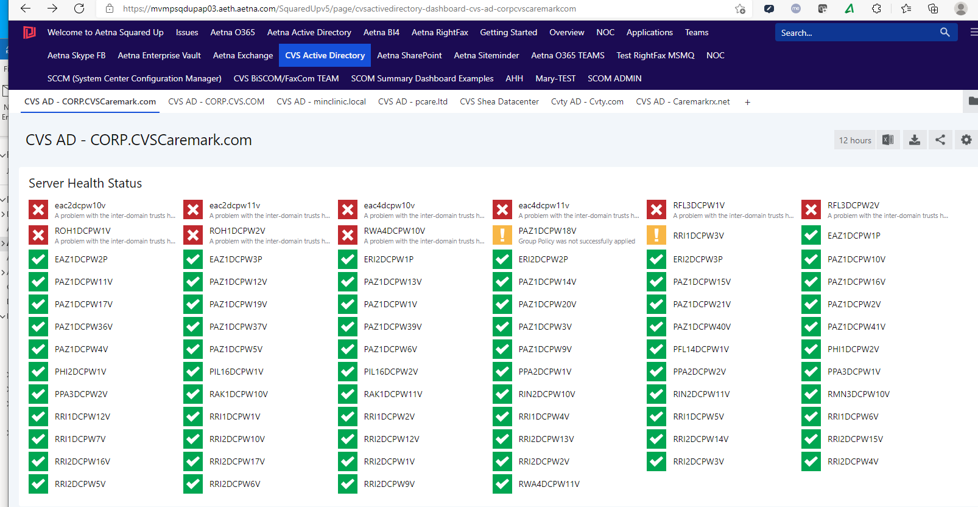

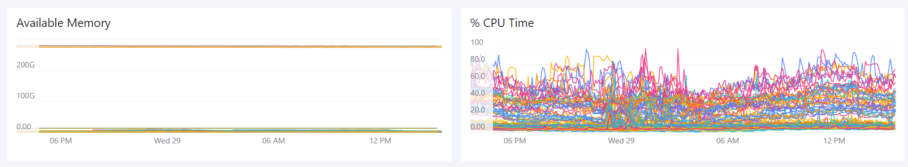

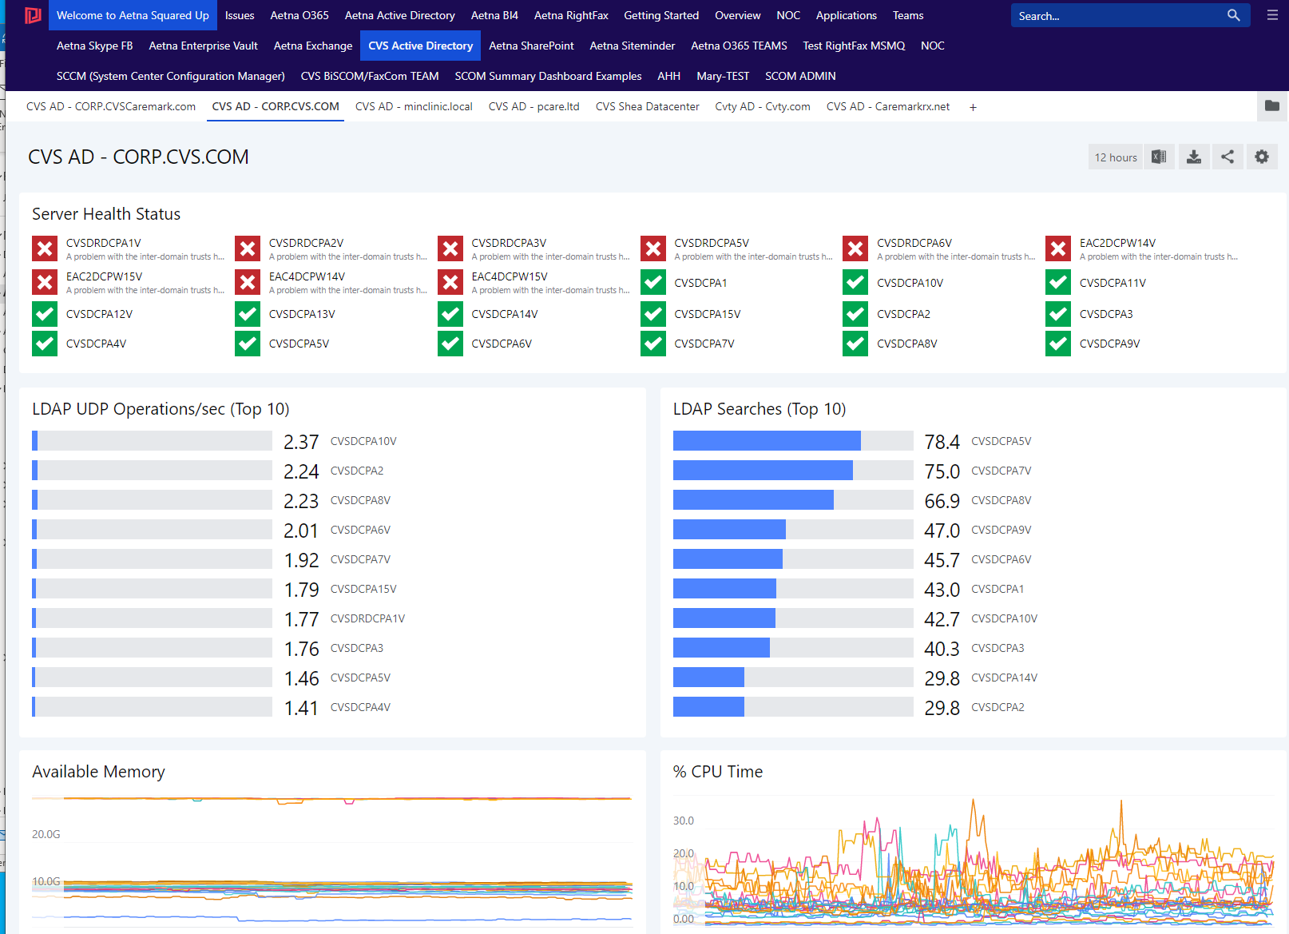

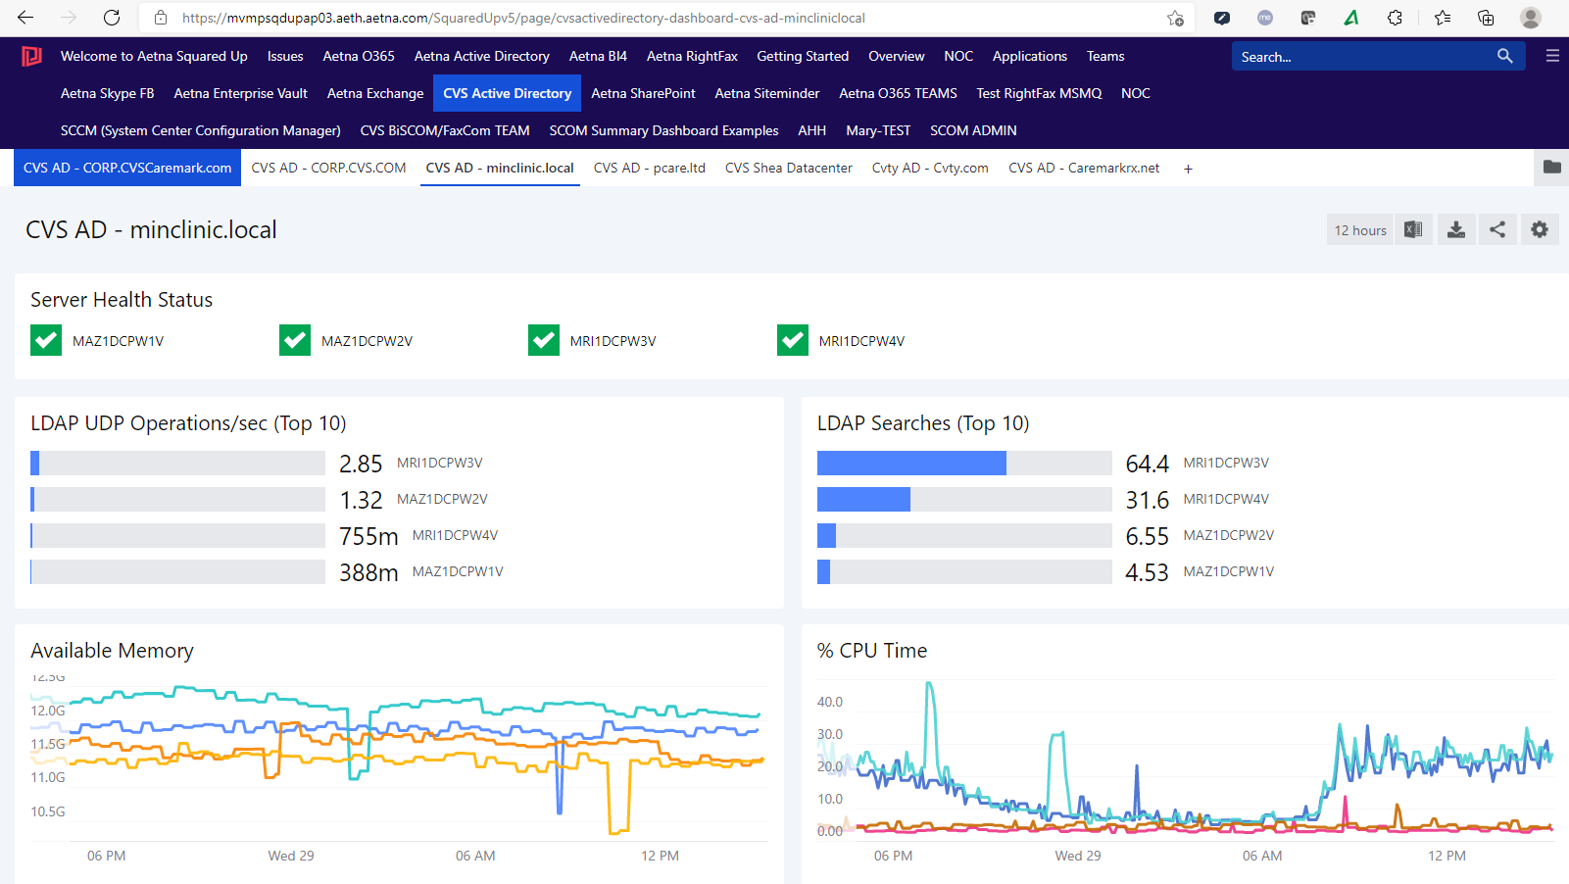

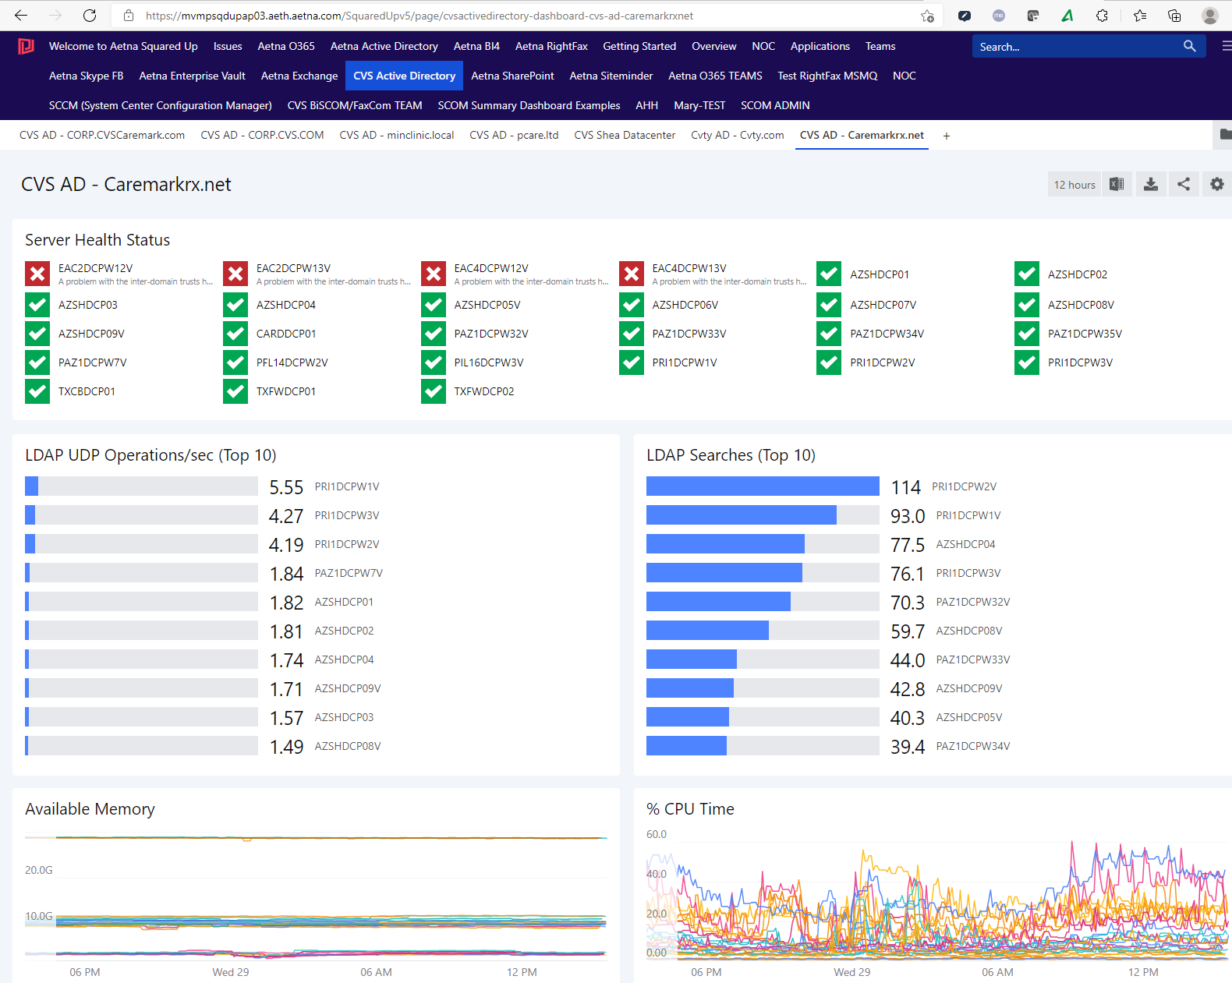

**Splunk Dashboards**

